**KERNEL SVM**

In SVM we used to find a boundary which could separate 2 classes so that we can clearly know the new observation point should be added to which class.

SVM helps to correctly place decision boundary but there is an assumption that: “data is linearly separable”.

Now, what if we are not even able to make a boundary?

-> These ponits cannot be separated using a line. In this case the data is non-linearly separable.

Thus KERNEL SVM is used.

A higher dimensional space

In this we take our non-linearly separable dataset, map it to higher dimension and get linearly separable dataset in both the svm algorithm, build a decision boundary of our dataset and then project all of that back into original dimensions.

**THE KERNEL TRICK**

THE GAUSSIAN RBF KERNEL

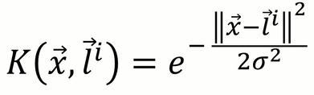

Used to separate the dataset.

TYPES OF KERNEL FUNCTIONS

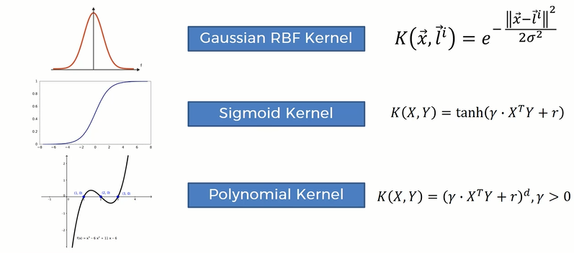

for more information about types of kernel functions go to the following link: mlkernels.readthedocs.io/en/latest/kernelfunctions.html